**Report on OOPS Project**

**A brief Introduction:**

Our Bus reservation system works on a global language and can be used to manage the buses in a city or interstate buses and in many countries it is happening but not on a large scale and it is not fully operational. It will be very useful for the common man who uses buses.

**Aim:**

To build a Bus Reservation system which performs several functions like adding buses on the server, reservation of buses, showing ticket availability and showing bus availability.

**Header Files Used:**

1. iostream: - Stands for input-output stream. This class contains definitions for various functions like cin, cout, many functions which are defined in other classes like vector but declared in this.
2. string: - This class is a part of STL and based on strings and makes it easier for the programmer to work with strings as it contains a lot of functions.
3. cstdlib: - This header file declares a set of general-purpose functions such as: atof() to convert string to double. It also contains a few mathematical functions.
4. conio: - It is a header file used in old MS-DOS compilers to create text user interfaces. This header declares several useful library functions for performing "console input and output" from a program.
5. cstdio: - This library uses what are called streams to operate with physical devices such as keyboards, printers, terminals or with any other type of files supported by the system.

**IDE Used:**

We used Dev C++ as the IDE and the file containing source code has been uploaded separately.

**Some Screenshots:**

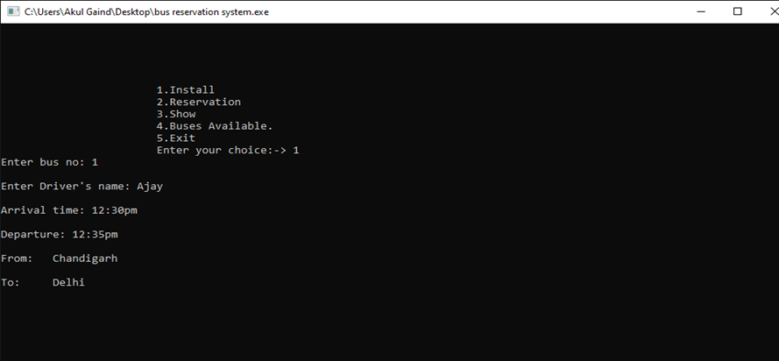

Installing a Bus Information

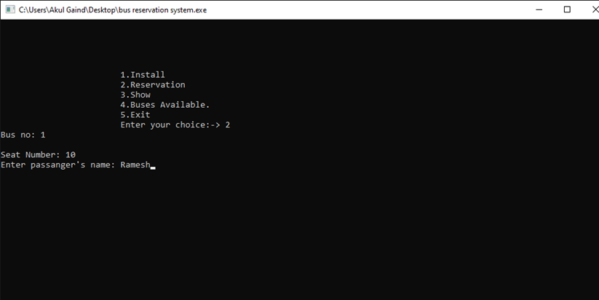

Reserving ticket for a Passenger

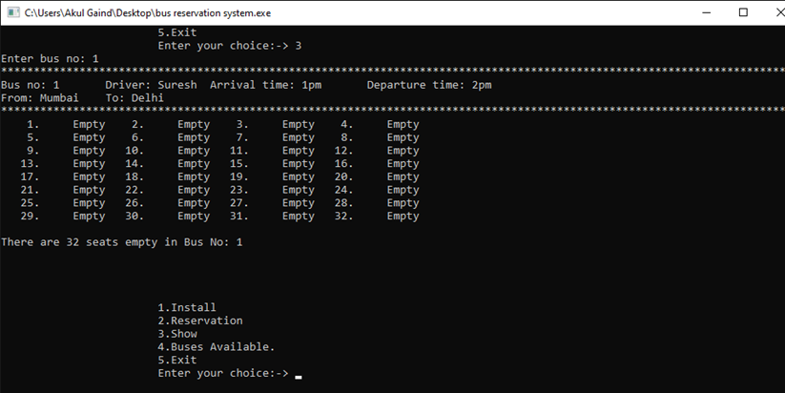

Checking Seats Availability

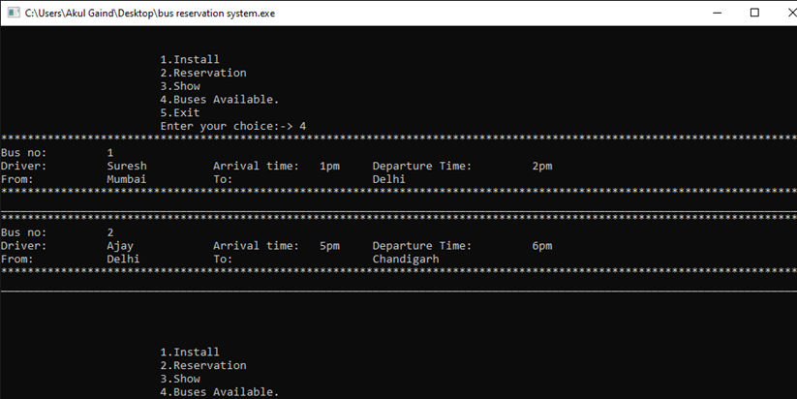

Showing Buses Available

**Project Members:**

Akul Gaind(CO19306)

Darshan Saraswat(CO19320)

Tushar Rana(CO19369)